**Transmission Chain Experiment**

**Summary of Experiment:**

In this experiment, four groups of four are formed in order to recreate a short story. The first group of four, which itself is divided into four different sections (thus creating four separate “chains” of four separate people), is given the original short story and is allowed three minutes to read it over. After three minutes have passed, they are all allowed 3-8 minutes to rewrite the story to the best of their ability. Their writings are then collected and checked for readability, and then are scored based on how many propositions from the original story are present in the recreations. The game then continues with the next group reading from the previous group’s associated chain member’s recreation. This continues for the rest of the groups, after which all data collected from the scorings of the recreations are compiled into an excel sheet.

**Scoring:**

The scoring of the recreations of the original story is based around four types of messages represented in the data (social gossip, social non-gossip, etc.) each with an equal number of propositions, and how many of these propositions are present in the subsequent recreations of the original based off of the previous chain’s recreation. These scores are then compared to the other scores in its chain to determine how the transmission process changed how accurate subsequent chains are.

**Hypothesis:**

If the fidelity of information transmission depends on the social content of the message, and we construct a story with four types of messages (social gossip, social non-gossip, etc.), each with an equal number of propositions, and pass it along a transmission chain, then we predict that more propositions will be preserved from the social categories than from the nonsocial ones.

**Null Hypothesis:**

If there is no difference in message fidelity, then there should be no difference in the number of propositions preserved.

**Data:**

Horizontal Axis for “Chain ‘x’” table:

* 1 = Social Non-gossip
* 2 = Social Gossip
* 3 = Nonsocial Physical
* 4 = Nonsocial Individual

Horizontal Axis for “Total # Propositions Chain ‘x’”

* X = Player X

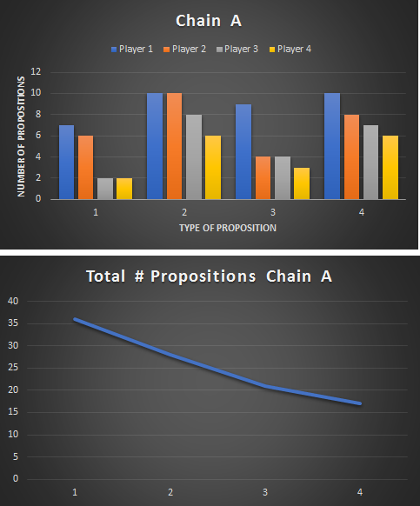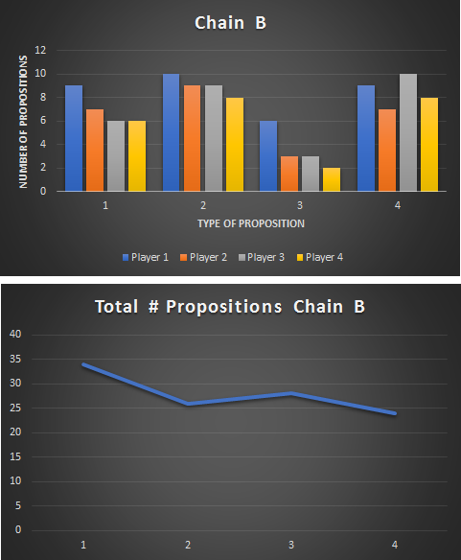

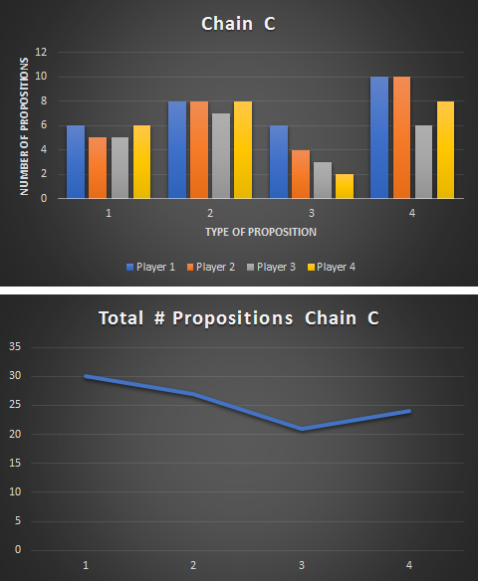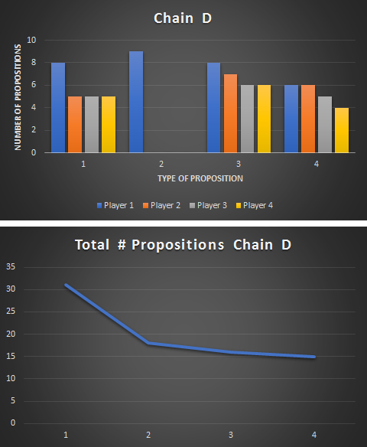

**Summary of Data:**

Given the data above, there is an obvious decline in fidelity of propositions from chain link to chain link for all four chains, with the only real outlier being the total number of propositions in Chain C from Player 3 to Player 4. The breakdown of the data in terms of the average difference between the first link of a chain to the last link of the same chain:

|  |  |  |  |  |
| --- | --- | --- | --- | --- |
| Type of Proposition | Social Non-gossip | Social Gossip | Nonsocial Physical | Nonsocial Individual |
| Average Difference | 2.75 | 3.75 | 4 | 2.25 |

Thus the average difference between the first link and last link of all chains in the social category is 2, and the average difference between the first link and last link of all chains in the nonsocial category is 3.125.

These averages prove our hypothesis, that more propositions from the social category of propositions are preserved through the chain than from the nonsocial category. This promotes the idea that social propositions are more memorable to readers, and thus are more likely to be passed on accurately than non-social propositions.

**Strengths/Weaknesses in this Experiment:**

This experiment is overall a good example of a simple transmission chain and how the preservation of original information throughout the chain usually declines. The major fallback of this particular experiment would be the difference in memory retention in specific players. This can be seen in Player 2 of Chain D, who failed to remember/write down any of the Social Non-gossip propositions, a fluke when compared to the rest of the chains. Another weakness of this experiment could be various distractions that could come about in the environment during one player group’s memorization/recollection phase, which could skew the numbers for other groups who did not have said distraction.

The major strength of this experiment is the multiple number of chains, which provide an average that could cut out outliers which could exist in a 1 to 2 chain experiment. Another strength is the legibility checking after each group finishes their writing phase, which can eliminate confusion and time loss in the next group.